User Training Manual – Sales and Marketing

Prepared for

**Technica International**

Version: **2.0**

Prepared by:

Ahmad Hussein

Contributors:

Mahmoud Karim

Table of Contents

01.

Introduction

02.

Customer creation

03.

Sales processes for project

04.

Sales and marketing reports

|  |
| --- |
| CONTENTS |

**INFO-SYS| TRAINING DOCUMENT** **01**

|  |
| --- |
| INTRODUCTION |

* 1. **Purpose**

The purpose of this document is to provide users with practical guidance on managing sales and customer-related processes within Microsoft Dynamics 365 Finance and Operations. It explains how to create and manage sales quotations, orders, and returns, as well as how to maintain customer information.

* 1. **Scope**

This training manual covers the key functionalities of the Sales and Marketing module. It also introduces basic sales reporting and inquiry functions.

1. **Sales and marketing configuration**
   1. **Customer creation**
2. Sales and marketing > Customers > All customers > Click new

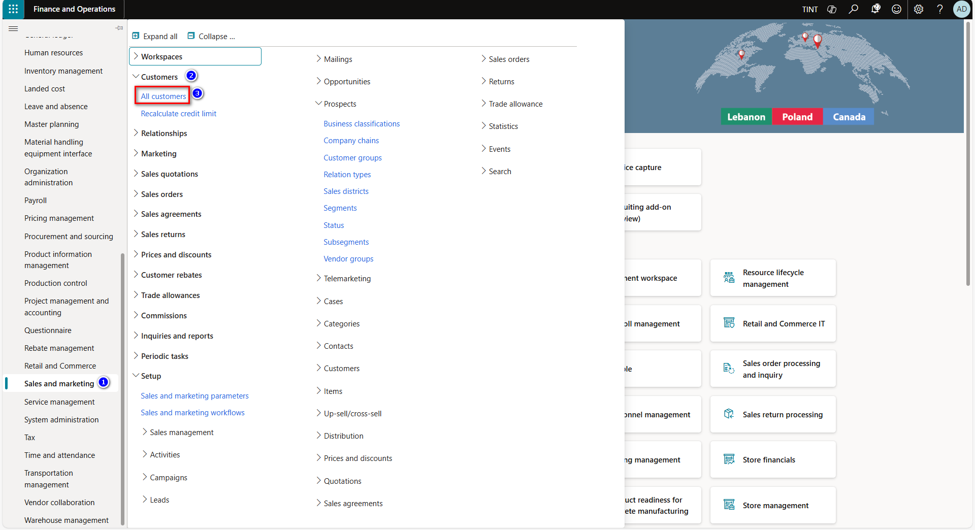

1. Record type: Select whether the customer is a person or an organization.
2. Enter customer name in Name field.
3. Select and assign the customer group in group field.
4. Select the currency of the customer. The currency that is automatically entered on invoices to the selected customer.
5. Select the terms of payment of the customer.
6. Select the sales tax group.
7. Select the country of the customer.

1. Under customer > accounts > contacts. Select add contact to add contacts to the customer record

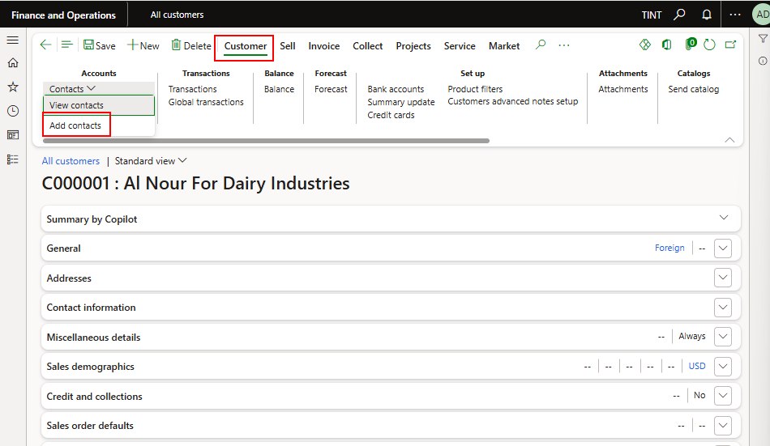

* 1. Add general details such as the first name, last name and the contact information

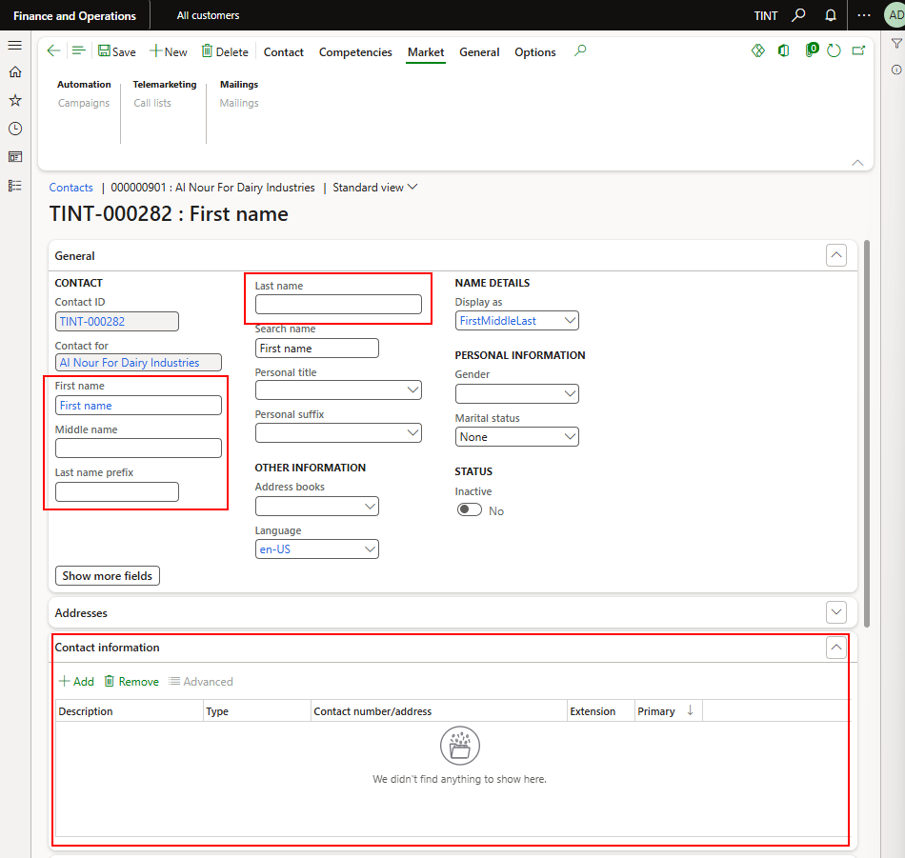

1. Under customer > setup. Select bank accounts to enter the bank accounts for the customer
   1. Click New
   2. Add bank details

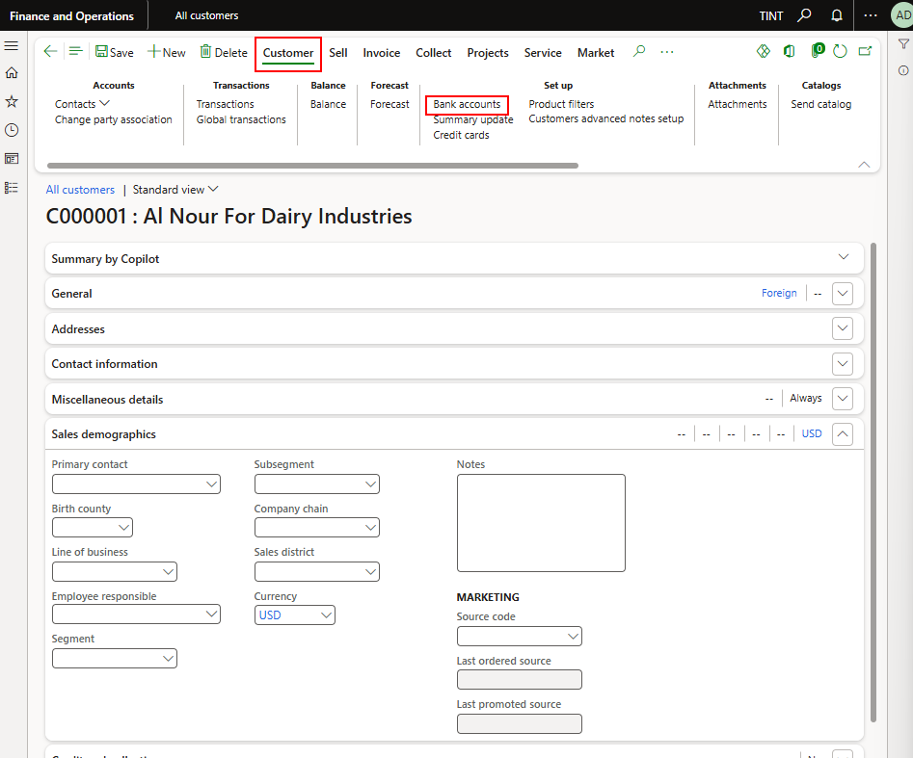

1. Under the addresses tab, enter the customer’s address. You can enter multiple addresses for the same customer.
   1. In the name or description enter the address description (head office for example)
   2. In the purpose field, enter or select a value. You can select one or more purposes. These are used to select the correct address for a given purpose. For example, if the purpose is “invoice” that address will be used when you send invoices.
   3. In the country/region field, enter or select a value. Enter the address details. The country/region that you selected will determine the fields you are presented with, corresponding to the address format for the country/region.
   4. Click ok

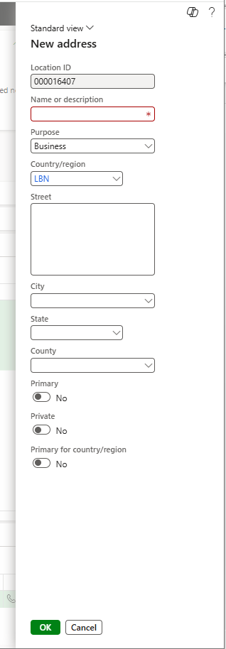

1. Under the contact information fast tab provides the contact information for the customer
2. Under the miscellaneous details fast tab indicate the following:
   1. Country/region the customer belongs to
   2. Select the direct delivery checkbox if the customer’s sales orders are fulfilled using direct delivery

1. Under credit & collections tab, specify the credit rating & credit limit of the customer of it exists

1. Under sales demographics, specify the primary contact from the list added in point 9

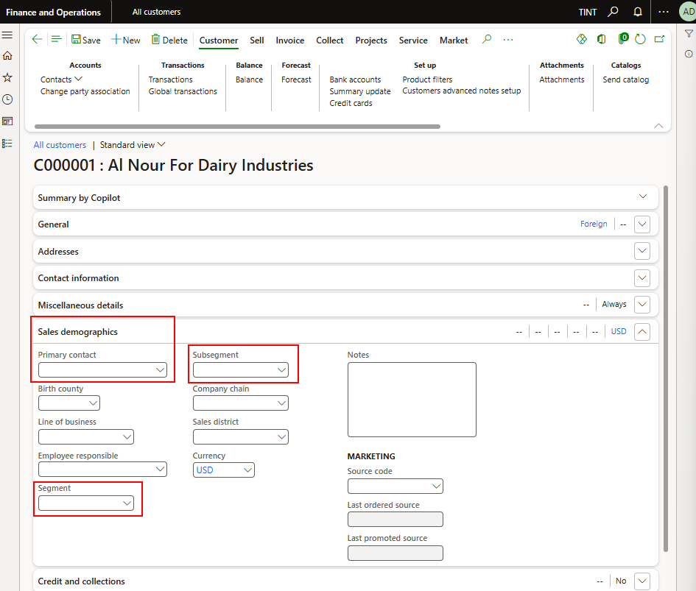

1. Under the payment defaults fast tab select the following:
   1. Terms of payment.
   2. Method of payment.
   3. Customer’s primary bank account from the list created in point 10.

1. In the invoice and delivery fast tab, specify the following:
   1. Customer’s invoice account.
   2. Delivery terms & mode of delivery defaulted on customer transactions.
   3. Sales tax group that is defaulted on customer transactions

1. To view or add activities associated directly to the customer. Under general > activities. Select activities drop-down.

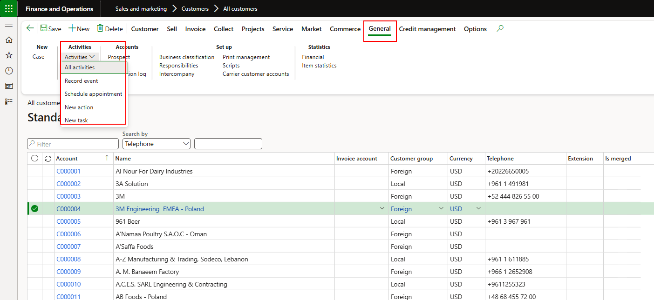

1. **Sales processes for project**

The sales process related to project starts with creating a prospect then adding the contacts and activities for this prospect.

This prospect is converted to a lead, and the lead information will be updated accordingly

The lead will be converted to an opportunity, and a project quotation will be created from the opportunity.

The tendering team will be notified.

1. **Create prospects**
2. Sales and marketing > Relationships > Prospects > All prospects

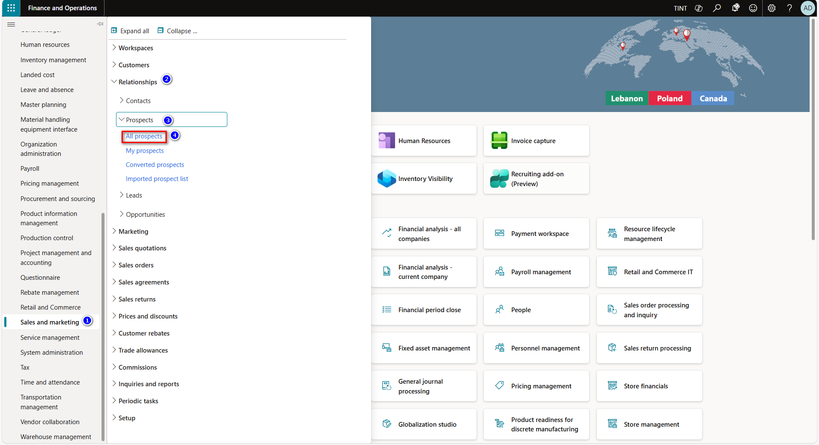

1. Click new to create a new prospect.
2. Enter the prospect name.
3. Select the type of prospect.
4. Select the currency of prospect.
5. Select the country of prospect.

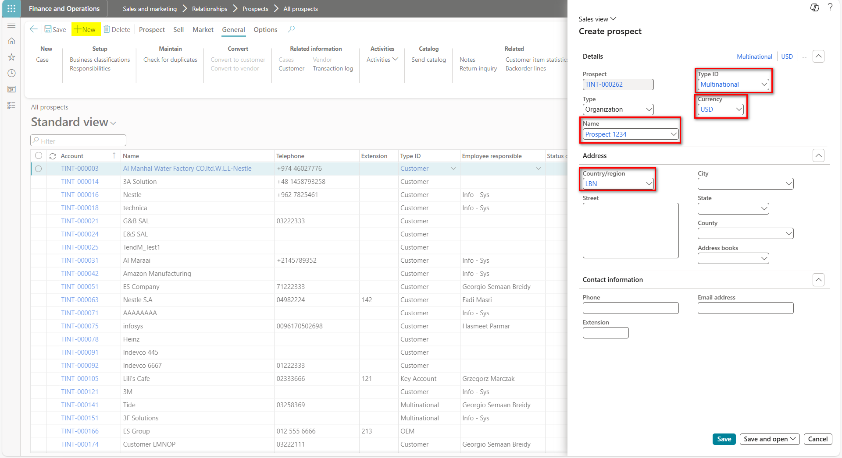

1. From general tab specify the following
2. Account source of the prospect.
3. Country.
4. Prospect nature.
5. Status.
6. From general fast tab specify the activities of the prospect.

1. From prospect fast tab specify the contacts of the prospect.
2. From sales demographics tab specify industries of the prospect.

1. **Create lead**
2. From the prospect screen > Sell > New. Select Lead

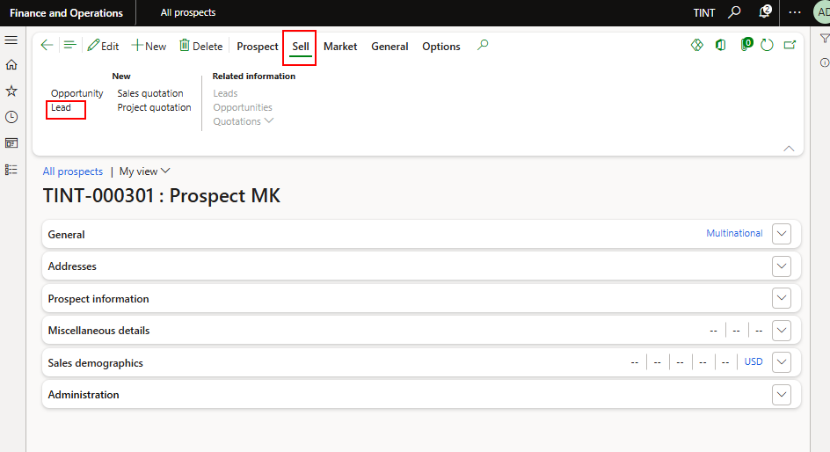

* 1. A new lead record will be created
  2. Under General, specify the following
  3. Type
  4. Priority
  5. Rating
  6. Sales unit
  7. Source and source ID (If creating lead from the prospect, the source type and ID will be filled automatically.
  8. Notes

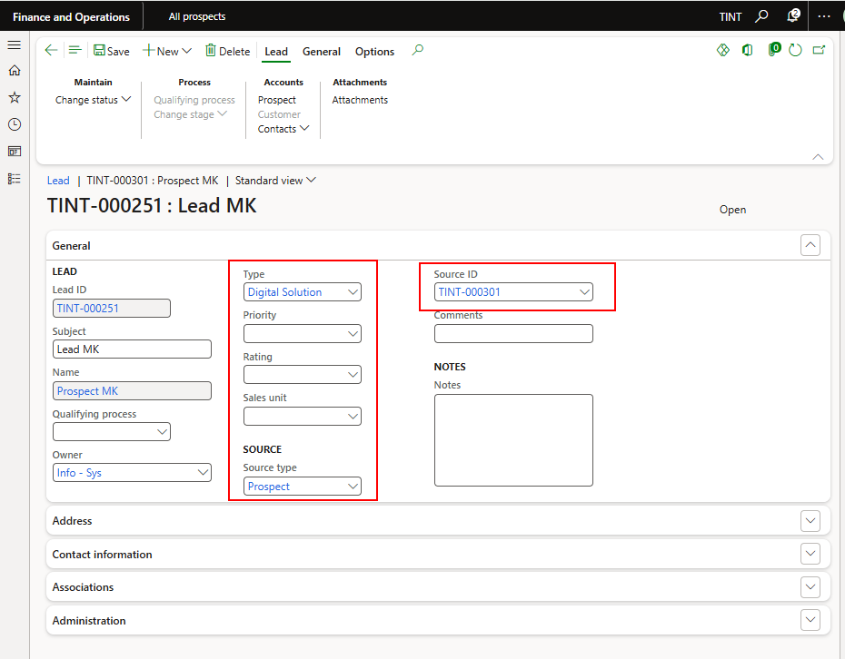

1. Under contact section, specify contact information

1. Under Lead > Accounts. You can add contact to the lead

1. **Create opportunity**
2. From the lead > generate > opportunity

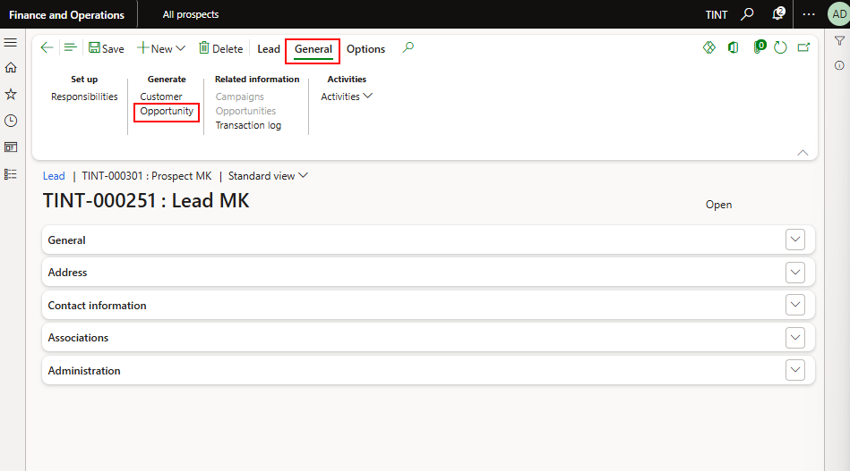

1. From general tab specify the following on the opportunity.
2. Subject of the opportunity.
3. Estimated closing date.
4. Sales process.
5. Offer deadline.
6. Offer type.
7. Opportunity type.
8. Primary contact. To add contacts to the opportunity. Under Opportunity > accounts > contacts > add contacts. After ending one or multiple contacts, select the primary contact for the opportunity under general.

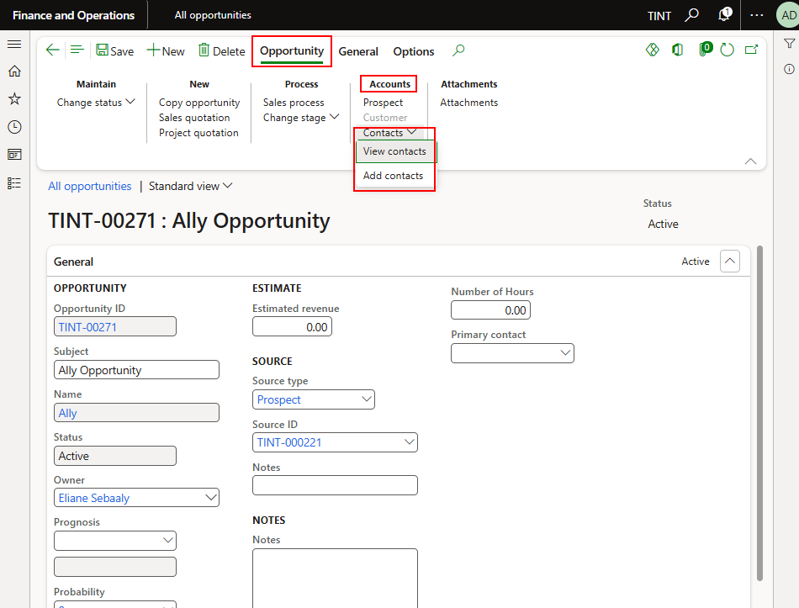

1. Under Buyers, specify buyer, name, buyer influence, type, support to offer, buyer profile, You can add up to 4 rows only.

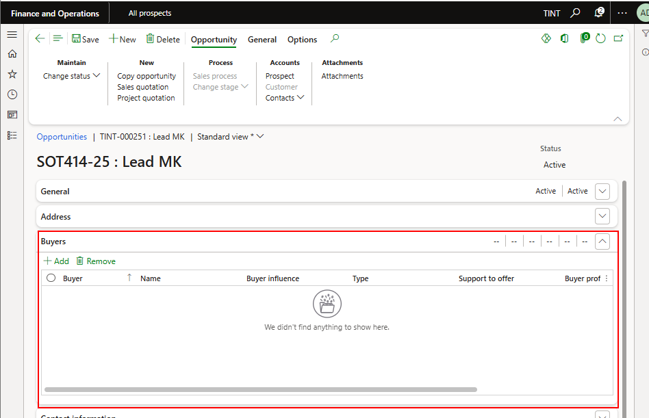

1. Under competitors tab, specify competitor, competitor relation/status with customer, type of solution, chances to win, location of support, main strengths and advantages, main weakness and inconvenience.

1. Under win/lost reason, specify delivery, analysis of buyers, technical solution rating as seen by customer, quality of equipment, lead time, price level compared to Technica, technology evaluation

1. Under closing feedback, specify if the opportunity is a case study, project awarded to, feedback, what was the turning point in the decision, what should we have more or better

1. From general tab > activities. You can add activities to the opportunity.

* 1. Select the type of activity
  2. Specify the purpose, location, plan (here you can specify for example trip to categorize all activities related to trips), start and end time, responsible person, and description

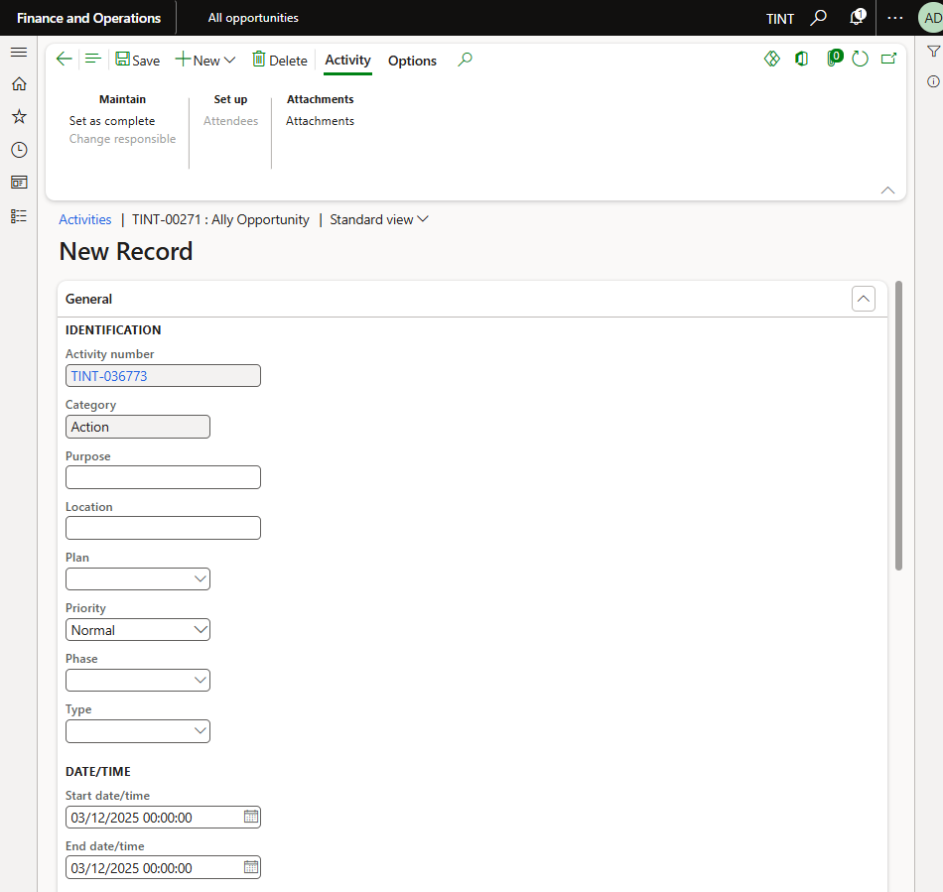

1. Under opportunity > attachments. Select attachments to add attachments to the opportunity record.

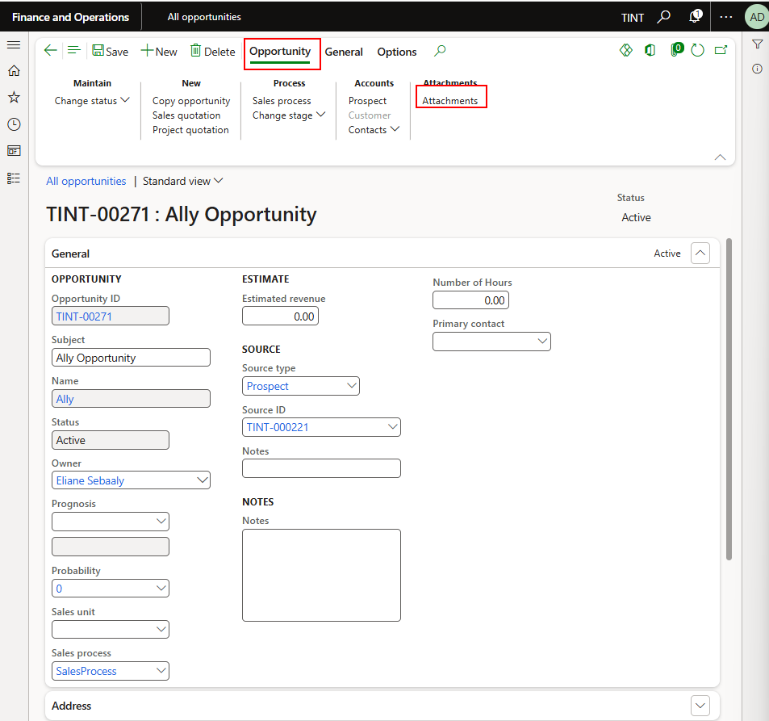

1. From opportunity tab > process > change stage drop-down, change the stage of the opportunity. To move between stages the buyer tab and the competitor tab are mandatory and need to be completed. It is also possible to move backward between stages.

1. Change the status of the opportunity to win/lost/postpone/cancel. In case the win/lost reason tab and the closing feedback tabs are not filled in, they will show in the dialogue when changing the status to win/lost.

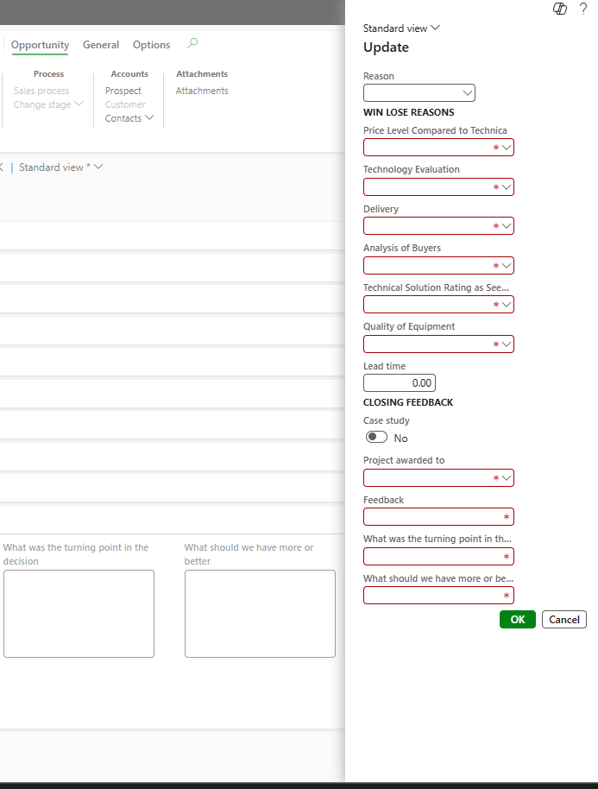

1. **Create project quotation from the opportunity.**
2. From opportunity > New. Select the project quotation.

1. After the creation of the quotation, a notification will be sent to the tendering team to complete the project quotation.
2. **Sales and marketing reports**
3. **Customers**

* This report provides a simple list of all customers that are set up in the system. It displays key customer information such as customer account, name, address, currency, and payment terms.
* Sales and marketing > Inquiries and reports > Customers > Customer report

1. **Customer base data**

* This report contains detailed information from the customer master record, including customer group, settlement terms, tax information, bank account details, and contact information.
* Sales and marketing > Inquiries and reports > Customers > Customer base data

1. **Sales orders per customer**

* Shows all the sales order group by customer
* Sales and marketing > Inquiries and reports > Sales order reports > sales orders per customer

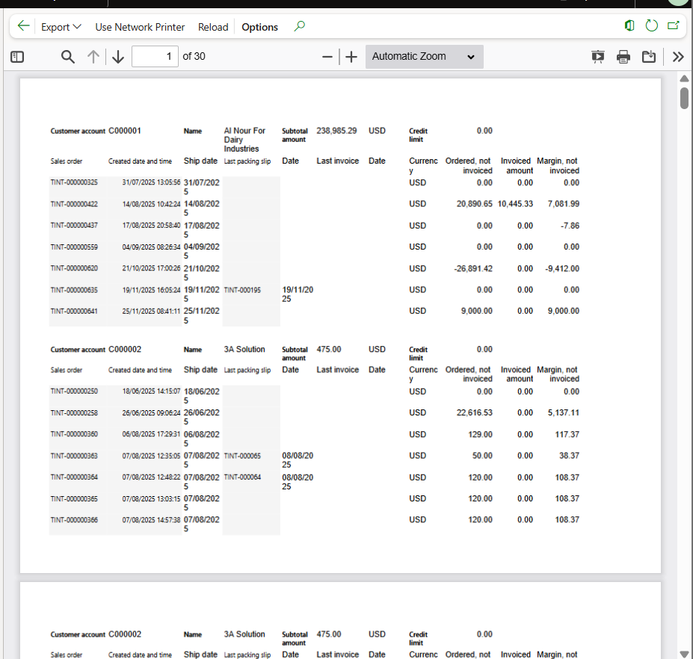

1. **Open sales order lines by ship date**

* This report shows all sales order lines that are still open (not fully delivered or invoiced) and organizes them by their expected ship date.
* Sales and marketing > Inquiries and reports > Sales order reports > Sales order lines

1. **Sales and probability performance**

You will be able to see the following BI reports:

* + Revenue by customer
  + Revenue by product
  + Revenue by period
  + Revenue by location
  + Customer profitability
  + Profitability analysis
* A screenshot of a computer

  AI-generated content may be incorrect.

1. **Customer/Item statistics**

* This report summarizes sales activity by customers, showing the quantities and values of items sold for each customer over time.
* Sales and marketing > Inquiries and reports > Customer statistics > Customer/item statistics

